**DSA Assignment**

**Name:** Faizan **CMSID:** 023-23-0318

**Section:** A **Date:** 10-11-2024

**Lab 9 Solutions**

**Task 01**

* Understand the provided code and implement all the method of Binary Tree with proper exception.

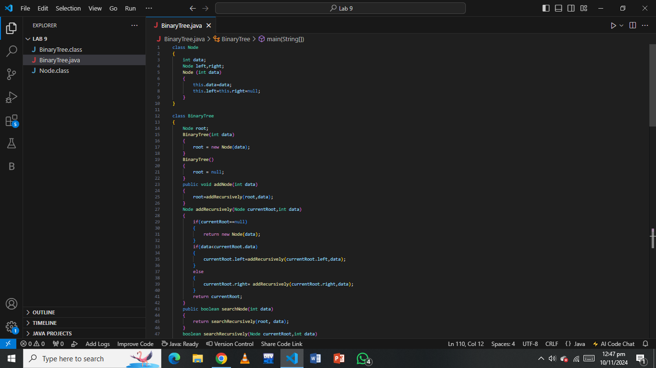

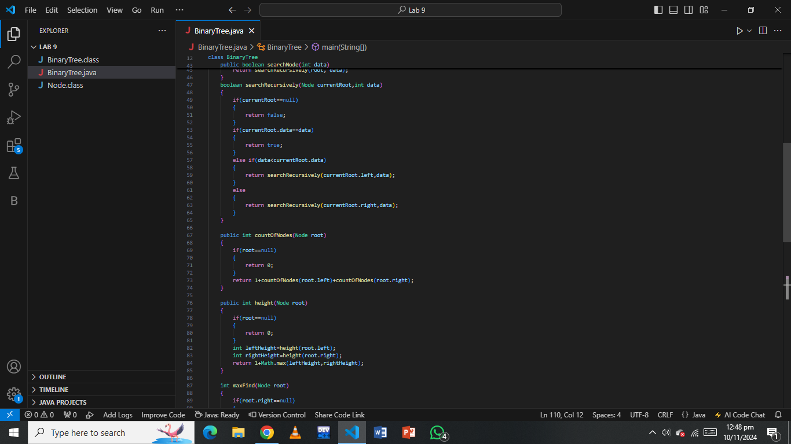

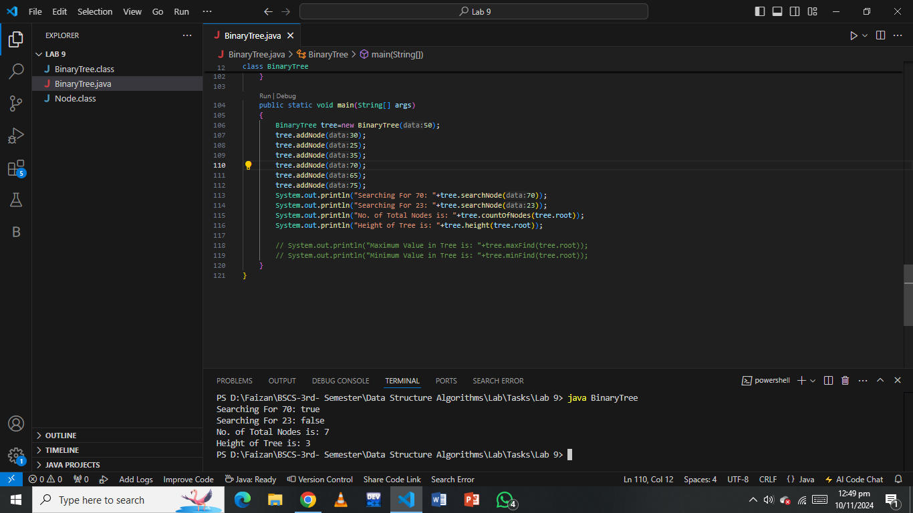

**Task 02**

* Write two methods minNumber() and maxNumber(), which return minimum value and maximum value from binary tree respectively.

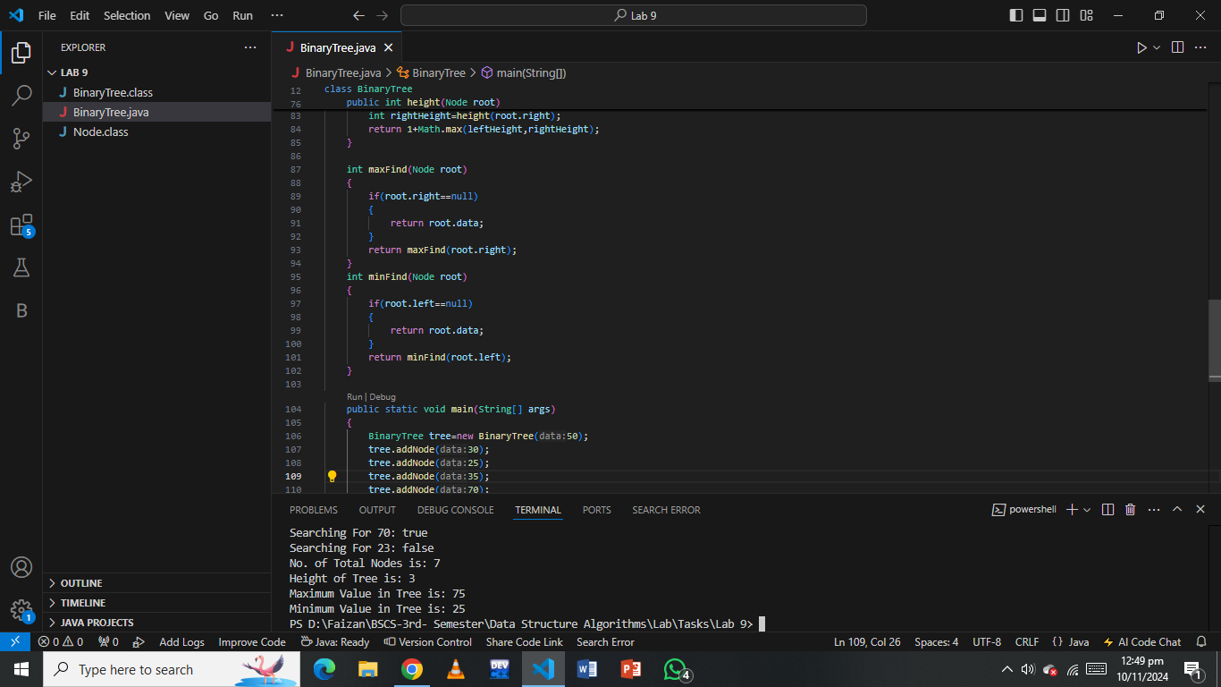

**Task 03**

* Write a function balanceTree(Node root) to determine if binary tree is height balanced or not.

